May Memorial Baptist Church

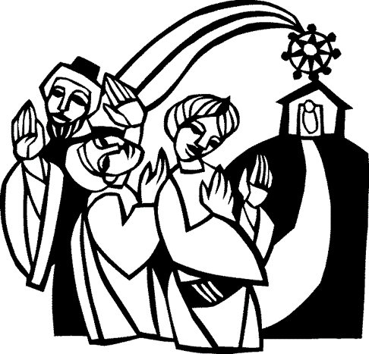

The Sunday of the Epiphany

January 7, 2018

This is the House of God…All Are Welcome

The Community Gathers for Worship

Prelude Carol Williams

Welcome and Announcements Michael Edwards

* Call to Worship Ashley Edwards

We gather in the Light
that was before, is now, and ever will be.
We seek the Light’s ancient wisdom.

We gather in the Light
that is God’s continuing gift.
We live into the Light’s new wisdom.

We gather in the Light
that is our own, emerging anew each day.
We seek to share this wisdom,
nurtured in the Light from Bethlehem’s cradle.

* Hymn of Praise No. 117
As with Gladness Men of Old

* Invocation Michael Edwards

The Community Proclaims and Hears God’s Word

Children’s Sermon Ashley Edwards

As Jesus Loves the Little Children is sung all children are invited to come to the front of the sanctuary for Children’s Time. After the Doxology, children ages 3 through Kindergarten who remained in worship with their families may exit the sanctuary for Extended Session.

* Offertory Hymn No. 122
Tell Me the Story of Jesus

Worship in Stewardship
Offertory Prayer Ed Utt
Presentation of Gifts Irma Alvis
* Doxology 253

Solo Mark Worsham

Gospel Lesson Jeff O’Donnell
Matthew 2:1-12

Sermon Michael Edwards

The Community Responds to God’s Word
* Response Hymn No. 377
Jesus, at Your Holy Table

Celebration of the Lord’s Supper
Invitation to the Table

(Communion will be taken by intinction, the practice of partially dipping the bread into the cup before consumption. Please come forward down the center aisle by rows, beginning with the front row on each side, and then return to your pew back down the side aisles. Each pew should follow the pew in front of them. All bread is gluten free.)

The Story
Prayer (ending with the Lord’s Prayer)

Our Father, which art in heaven, hallowed be Thy name. Thy kingdom come. Thy will be done on earth, as it is in heaven. Give us this day our daily bread. And forgive us our trespasses, as we forgive those that trespass against us. And lead us not into temptation, but deliver us from evil. For Thine is the kingdom, and the power, and the glory, forever. Amen.

The Community Departs for Ministry

* Benediction Michael Edwards
Hymn No. 387
Blest Be the Tie (v. 1 only)
Blest be the tie that binds our hearts in Christian love
The fellowship of kindred minds is like to that above.

* Postlude Irma Alvis
Irma Alvis, Organist
______________________________________________________________
* Please stand as you are able.

Youth Lock In—Next Sunday, January 14 to Monday, January 15.

Mid-Week Meals—This week we will be having Pot Luck. Please bring a dish, no reservations are required. There is no charge for the meal. On the 18th the Rachael Circle will be cooking several homemade soups and making salad.

Team Ministry:
Backpacks of Love—Tuesday at 7:00 p.m. at Aerations Plus
Prison Ministry—Thursday Night at 6:00 p.m.
Food Pantry—Saturday, January 20, 9:30 a.m.

WMU Circles:

Anna Circle—will not meet in January. Please collect your items for the homebound. We will meet in February, more information about that meeting will be announced soon.

Rachael Circle—The Circle will gather and will be preparing the Thursday night meal on January 18. Soups and Salad are the menu. The proceeds will fund our missionary commitments. The next meeting will be on February 13 and we will be doing something fun for Valentines.
This Week at May Memorial

Sunday, January 7
9:45 a.m. Sunday School
11:00 a.m. Worship
2:00 p.m. Deacons Meeting
6:00 p.m. Youth Soul Food
Monday, January 8
7:30 p.m. AA/NA Meeting
Tuesday, January 9
7:00 p.m. Backpacks of Love
Thursday, January 11
9:30 a.m. Christmas Mother Meeting
5:45 p.m. Mid-Week Meal
6:00 p.m. Prison Ministry
6:15 p.m. Handbells
6:30 p.m. Business Meeting
Children’s Mission
7:00 p.m. Children’s Choir
7:30 p.m. Adult Choir

Ashley Edwards,
Youth/Children’s Minister
Beverley Edwards,
Minister of Music
Michael Edwards, Pastor
(804) 922-0101

