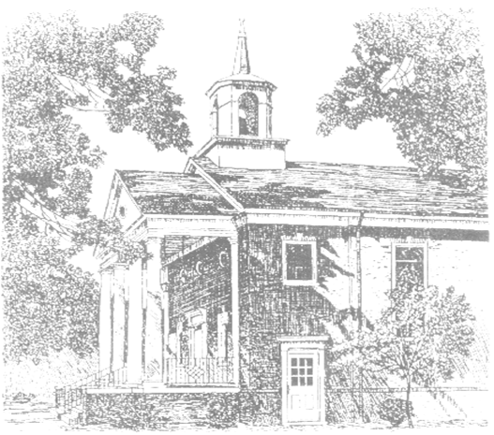
May Memorial Baptist Church

August 12, 2018
10:00 a.m.

The Community Gathers for Worship

Welcome and Announcements Michael Edwards

Prelude Carol Williams

Gathering Song No. 388 OLD 134TH
Our God Has Made Us One (St. 1)

Call to Worship Payton Sanudo

The earth is the Lord’s, for he made it:
Come, let us adore him.
Worship the Lord in the beauty of holiness:
Come, let us adore him.
The mercy of the Lord is everlasting:
Come, let us adore him.
Lord, open our lips.
And our mouths shall proclaim your praise.

* Hymn of Praise ST. BRENDAN’S
They’ll Know We Are Christians

1-We are one in the Spirit, we are one in the Lord.
We are one in the Spirit, we are one in the Lord.
And we pray that all unity may one day be restored.
REFRAIN
And they'll know we are Christians by our love, by our love.
Yes, they'll know we are Christians by our love.
2-We will walk with each other, we will walk hand in hand.
We will walk with each other, we will walk hand in hand
and together we'll spread the news that God is in our land. REFRAIN
3- We will work with each other, we will work side by side.
We will work with each other, we will work side by side.
And we'll save each one’s dignity and guard each one’s pride. REFRAIN
4- All praise to the Father from whom all things come.
And all praise to Christ Jesus His only Son.
And all praise to the Spirit who makes us one. REFRAIN

- * Invocation Michael Edwards

The Community Proclaims and Hears God's Word

Children’s Sermon Ashley Edwards

Children are invited to move to the front of the sanctuary as all sing Hymn No. 592, Jesus loves the little children, all the children of the world. Ev’ry color, ev’ry race, all are covered by His grace; Jesus loves the little children of the world. After the Doxology, children ages 3 through Kindergarten who remained in worship with their families may exit for Extended Session.

Words of Thanksgiving Tricia Flippo

Call to Prayer No. 658 WHELPTON
Hear Our Prayer, O Lord

Pastoral Prayer (ending with the Lord’s Prayer) Michael Edwards
Our Father, who art in heaven, hallowed be Thy name. Thy kingdom come. Thy will be done on earth, as it is in heaven. Give us this day our daily bread. And forgive us our trespasses, as we forgive those that trespass against us. And lead us not into temptation, but deliver us from evil. For Thine is the kingdom, and the power, and the glory, forever. Amen.

* Stewardship Hymn No. 273 FREELY, FREELY
Freely, Freely

Offertory Prayer Ed Utt
Offertory Irma Alvis & Carol Williams
* Doxology and Presentation of Tithes and Offering

Gospel Reading Josh Deal
John 8:1-11

Sermon Michael Edwards

The Community Responds to God's Word

* Hymn of Response No. 277 HENDON
Take My Life, and Let It Be Consecrated

The Community Departs for Ministry
* Benediction Michael Edwards

* Congregational Response ST. BRENDAN’S
And they'll know we are Christians by our love, by our love.
Yes, they'll know we are Christians by our love.

* Postlude Irma Alvis
___________________________________________________________________________
* Please stand as you are able

Sanctuary Flowers
The flowers in the sanctuary are placed by Tricia and Ewell Flippo
in memory of Joyce Maxey on her birthday.

The new pew cushions in the May Memorial sanctuary are given in memory of Joyce Maxey. Joyce was a faithful member of May Memorial Church and her love for God and His Church is an enduring legacy. May Memorial is grateful for the generosity of the donor and all who worked to ensure the beauty of this lasting gift.
Irma Alvis, Organist
Ashley Edwards, Youth/Children’s Minister
Joan Maples, Music Minister
Michael Edwards, Pastor (804) 922-0101
Website: maymemorialchurch.org
Church office: (804) 598-3098
We are saving a seat for you….
A New Powhatan Women's Bible Study
Discussing Beth Moore's "Stepping Up"
A study of Psalms. Tues. September 4 at 9:30 am. And every other Tuesday
Through December 4th at May Memorial
For details and to register please contact Sandra Cowles at 804-376-7901.

Food Pantry Help Needed – 2 people are needed Wednesdays from 9-12 to pick up food. Call Teresa Fields at 389-9136.

CHOIR - FALL KICK-OFF PARTY AND POTLUCK!!!! Wednesday, September 5
6:30 p.m. at Irma Alvis's home
All who are currently singing and those who are interested in joining the choir are invited!
BBQ will be provided. Please bring a side dish!

Back To School Blue Grass Bash – Sunday, September 9 at 5:00 p.m. There will be a community event with food, children’s activities and music by the Little Mountain Boys. Deacons provide Hamburgers and Hotdogs and drinks. Please bring a side dish and a guest!

This Week At May Memorial

Sunday, August 12
9:00 a.m. Sunday School
10:00 a.m. Worship
6:00 p.m. Annual Meeting

Monday, August 13
7:30 p.m. AA/NA Meeting

Saturday, August 18
9:30 a.m. Food Pantry Ministry
____________________________________

Book Signing- On Sunday, August 26, Rev. Bill Hardison will host a book signing for his new book Dinosaurs in the Cornfield, the book recalls stories with his Grandpa. This will be at Bienvenue, across from Mable's Restaurant. The book signing is from 2:00 until 4:00, and everyone is invited.
Light refreshments will be served. If you would like to help by bringing a plate of cookies, let the church office know.

Love, Joy, Peace, Patience, Kindness, Generosity, Faithfulness, Gentleness, and Self-Control On Wednesday, September 12 we will begin a new Bible Study on the Fruit of the Spirit. Each week we will look at the individual traits that Paul lists in Galatians that make up a life lived in the Spirit. The study group will meet in the Gathering Room at 6:30 p.m.

