REGISTRATION FORM
Beth Moore’s “Stepping Up” a journey through the Psalms of Ascent
Location: May Memorial Baptist Church
Meeting dates: September 4th, September 18th, October 2nd, October 16th, October 30th, November 13th and December 4th, 2018.
Time: 9:30 a.m.-11:30 a.m.
Cost: $15.00 for study book

Please complete and return this form either to May Memorial Baptist Church at 3922 Old Buckingham Road, Powhatan, VA 23139 or contact Sandra Cowles at 804-376-7901, no later than August 14th, 2018.

NAME: ___________________________________________________________
MAILING ADDRESS: _________________________________________________
E-MAIL ADDRESS: __________________________________________________
PHONE NUMBER: ___________________________________________________
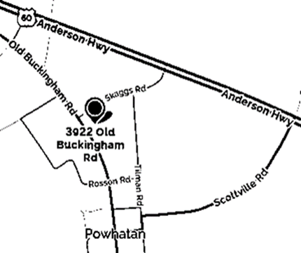
NEED DAY CARE: YES NO
If yes, how many children?________
What ages?____________________

We are so excited to have you join us!
Looking forward to starting our journey together!

